Interstitial Notes ~ Digital History

The log file is just your scratch pad for reminders to yourself of things like this, technical issues,
problems solved. Just save as a text file, call it log.md, and drop the log.md file into your repo.

- Throughout the whole module I would say that my biggest issue is uploading files to Github.

Week 1
- I liked the example given of Ikea and how it forces a Swedish identity by following the paths

Week 2
- Movement and enchantment
  - This helps to remember what you are looking at
  - When I went to pearl harbour, through an exhibit you could wear headphones that would play sound effects during certain sections
    - audio immersion!
- Mural!
  - Lots of fun
  - “Easy to use”
  - How to upload Mural to Github
    - Export
    - Extract zip file
    - Create new repo
      - make public
      - Add a README. File
    - Confirm
    - Upload all files from mural
    - Go to pages on Github settings
    - Branch from main
      - Wait a bit for link to appear

Week 3
- Checked out some really cool games
  - Atuel
  - Heritage Jam
  - End of the world
- Atuel made me think about my Unessay
  - I like how it is from Latin American culture
    - Should I do something from Latin American culture to learn more about my own family’s historical roots

Week 4
- My experience with Twine
  - A little difficult but easy
  - how do I get to one passage and make it go to another one?
- Twitter bots make no sense to my brain
- 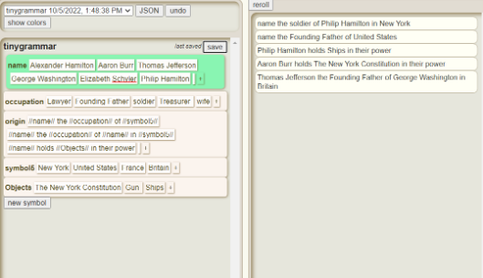
- 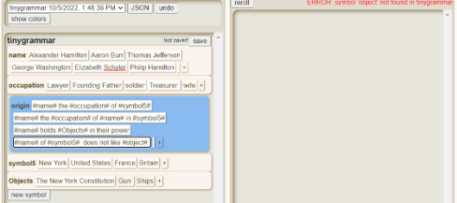
- I have been trying to upload my Twine page for the past half hour to 45 minutes
  - I follow the same process as i would to upload a mural file and go to pages to branch from main and yet it is still not working for me
- - The website that Github produces is not what I have uploaded on twine.
  - It shows a blank screen with a title
- 
 

